12.22 USE OF RESOURCES

The following describes the functionality and features included in Probe Audit Premium+

Objective

The objective of this document is to document the engagement team composition and confirm their declarations, assess the planned use of technological and intellectual resources, and evaluate the appointment and eligibility of the engagement quality reviewer.

The following key concepts of the Probe Audit Premium+ Methodology are set in this document:
- Engagement partner’s responsibility for sufficient and appropriate resource allocation (ISA 220)
- Confirmation of engagement team independence, ethical compliance, and professional competence
- Assessment of technological and intellectual resources needed for the engagement

Document placement
Document 12.22 – Use of resources can be found in the Audit planning folder in the Caseware document manager.
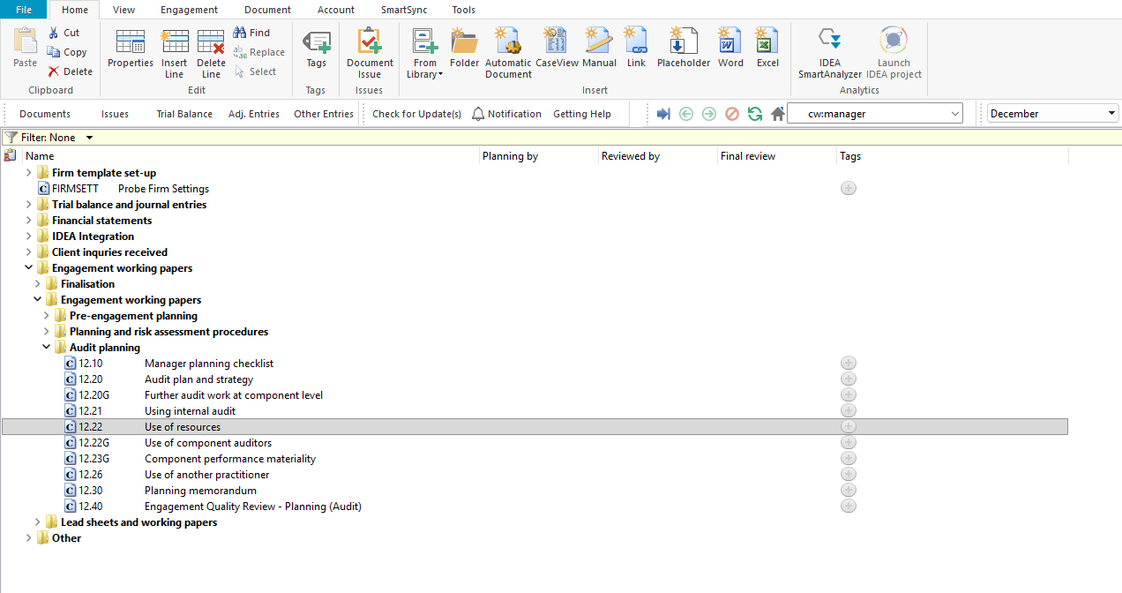

Document content
This document is designed to be a questionnaire and checklist type document with space for a comment or further description.
The document addresses the requirements of ISA 220 (Revised) – Quality Management for an Audit of Financial Statements and ISQM 1 – Quality Management for Firms that Perform Audits or Reviews of Financial Statements, or Other Assurance or Related Services Engagements. It covers the engagement team composition and declarations, the planned use of technological and intellectual resources, and the appointment and eligibility of the engagement quality reviewer.
This document is divided into different bookmarks in the document map to assist you in documenting the use of resources:
- Engagement team members
- Technological resources
- Intellectual resources
- EQ Reviewers
[Screenshot: Document map]

Layout
Column | Input Required | Outcome
Engagement team members
Firm personnel declarations | Read the declarations and confirm that each engagement team member has acknowledged the requirements relating to quality management, professional skepticism, ethical requirements, and independence. | No impact on the engagement file.
Signature table | Complete the signature table with the name, role, qualification, industry experience, engagement experience, comment, signature and date for each engagement team member. | No impact on the engagement file.
Technological resources
Question | No input is required in this column. Read the question and consider the matters listed. | No impact on the engagement file.
Yes / No | Select Yes or No to the question. | By answering the questions your engagement file will be tailored and further relevant questions will be shown in the engagement file (or hidden if not relevant).
Description | Provide a description or document the evaluation as required by the question. | No impact on the engagement file.
Risk | Record a risk or event by selecting the risk icon. | A risk or event will be recorded in the relevant risk table in the engagement file.
Ref. | Record a reference to supporting documentation. | No impact on the engagement file.
Intellectual resources
Question | No input is required in this column. Read the question and consider the matters listed. | No impact on the engagement file.
Yes / No | Select Yes or No to the question. | By answering the questions your engagement file will be tailored and further relevant questions will be shown in the engagement file (or hidden if not relevant).
Description | Provide a description or document the evaluation as required by the question. | No impact on the engagement file.
Risk | Record a risk or event by selecting the risk icon. | A risk or event will be recorded in the relevant risk table in the engagement file.
Ref. | Record a reference to supporting documentation. | No impact on the engagement file.
EQ Reviewers
Question | No input is required in this column. Read the question and consider the matters listed. | No impact on the engagement file.
Yes / No | Select Yes or No to the question. | By answering the questions your engagement file will be tailored and further relevant questions will be shown in the engagement file (or hidden if not relevant).
Description | Provide a description or document the evaluation as required by the question. | No impact on the engagement file.
Risk | Record a risk or event by selecting the risk icon. | A risk or event will be recorded in the relevant risk table in the engagement file.
Ref. | Record a reference to supporting documentation. | No impact on the engagement file.

Document outcomes

The engagement team members section must be completed to confirm that all firm personnel on the engagement have acknowledged their responsibilities relating to quality management, professional skepticism, ethical requirements, and independence. The signature table must be completed for each engagement team member.

The technological resources section must be completed to document whether technological tools, including IT applications, will be used to obtain audit evidence.

The intellectual resources section must be completed to assess whether intellectual resources other than those provided by the firm’s audit methodology and tools are required for the engagement.

The EQ Reviewers section must be completed to document the appointment, eligibility, and compliance of the engagement quality reviewer and assistants with the firm’s SoQM policies and procedures.

Group Audits

When the engagement type was selected as ‘Group Audit Single’ or ‘Group Audit Multiple’, questions are modified for the separate group audit engagement file.

Additional questions were added for group audit engagement to:
- Identify components for planning and performing of audit procedures;
- Determine expected involvement of component auditors in risk assessment procedures and further audit procedures;
- Evaluate access to components and component auditors; and
- Determine whether there is any indication that the group auditor will not be able to be sufficiently and appropriately involved in the work of the component auditor.

Some questions include red warnings or blue text in the description column. Follow the red warnings that inform you where key information should be recorded and the blue text in the description column that advises you where the understanding may be documented.

IN CONCLUSION

Features

The following features are available in the document:
- Insert or delete a comment, see page F3
- Insert or delete a row, see page F5
- Record a risk or event, see page F10
- Guidance, see page F16
- Freeze, see page F19

